**Summary Report Week 8**

**Patel Akshaykumar 1116561 (Student 1)**

**Topic:JUnit framework for Unit testing**

Overall this presentation was about implementing how to setup JBDC authentication using Spring Security.I created a login application using spring boot with two user details stored in H2 database and authenticating it using Spring Security in IntelliJ IDE.So first I started with explaining dependencies that are included in creating web page I.e.,Spring boot web starter.Next was H2 database starter , spring security starter and one dependency which I added manually was thymeleaf dependency used for creating HTML page for better UI showed in **Figure 1**.Moving onto the part of API using rest controller which I have included each and every file in ZIP included with the submission.Specially I have defined three API’s in Home Controller.java with Home Resource class and has 3 dependencies i.e.’/’for root URL which doesn’t need any right to access this page open for everyone.Next is ‘/user’ with a ROLE USER which can be accessed by role of user and admission.Last is ‘/admin’ which can only be access with right of ROLE ADMIN as shown in **Figure 2.** On the part of database,we know that e need schema of database termed as schema.sql & defined all the data rows of table inside data.sql but I have h2 database which doesn’t need any external connection.Spring boot has a facility which can be provided internally and defines in the Security configuration file with authentication & authorization process.Inside Authorization,we have defined rows of the table as user and admin and defined its username and password field respectively.Inside authentication,we first authenticate the right user whether it is requires a user access or admin access.Then direct to the self define HTML Login page (designed by me).Show the page for Login into it.Here shown are the output images of the application.**Dr.Jinan was concerned about how I added the dependencies is it all provided internally or I added manually.So the answer was all of them were added internally except one that is for thymeleaf for defining the html page as shown in the figure 1 below.**

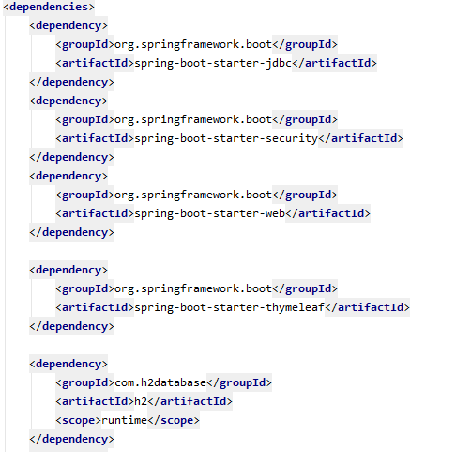

Figure 1

Home Controller.java

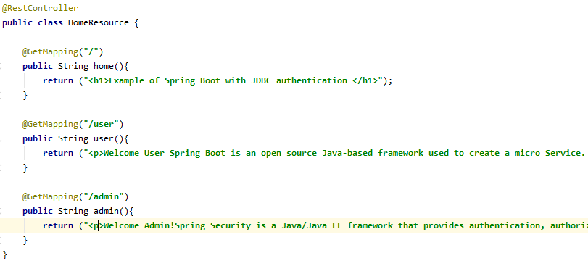

H2 Database schema

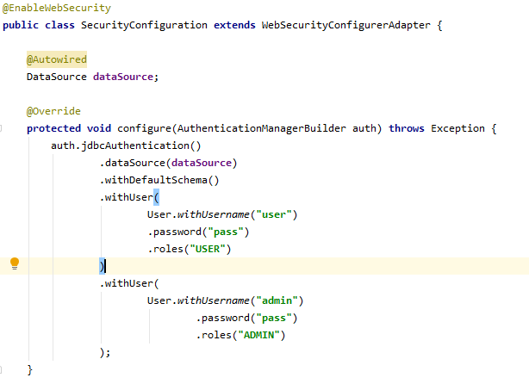

Steps for Running the application

1. Open the file in IntelliJ IDEA
2. Select the Tomcat server version according to your machine.
3. Go to browser and search localhost:8080/
4. Run the SpringSecurityConfiguration file and then will see in the run bar that server started and then go the browser and
5. Last enter Username as user/admin Password as pass for both of the cases .You will see the output accordingly

Conclusion:

Therefore on the part of conclusion,Login page with Spring boot for user and admin and authenticate it using Spring security in IntelliJ IDEA.

References:

https://www.w3schools.com/howto/howto_css_login_form.asp

https://www.thymeleaf.org/documentation.html

https://docs.spring.io/spring-security/site/docs/current/reference/htmlsingle/#user-schema

https://spring.io/projects/spring-security